|  |  |  |  |  |
| --- | --- | --- | --- | --- |
| **National University of Computer and Emerging Sciences, Lahore Campus** | | | | |
| C:\Users\saif\AppData\Local\Microsoft\Windows\Temporary Internet Files\Content.Word\final design.jpg | **Course:** | **Web Programming** | **Course Code:** | **CS-406** |
| **Program:** | **BS (Computer Science)** | **Semester:** | **Fall 2018** |
| **Duration:** | **180 Minutes** | **Total Marks:** | **40** |
| **Paper Date:** | **19-Dec-18** | **Weight** | **40 %** |
| **Section:** | **A/B** | **Page(s):** | **1 - 7** |
| **Exam:** | **Final** | **Reg. No.** |  |
| **Instruction/Notes:** | **Question 1 is for students of both sections. Section A is for section A students and Section B is for section B students.**  Do not bring any unauthorized material (e.g. written notes, notes in dictionaries, paper, sticky tape eraser etc.) Solve the question on the answer sheets.  Good luck! | | | |

**Question 1: Following is a snapshot of IMDb (an online database of information related to films, television programs, home videos and video games, and internet streams, including cast, production crew and personnel biographies, plot summaries, trivia, and fan reviews and ratings)**

* The home page displays Opening this week and Now playing (Box Office) as follows:

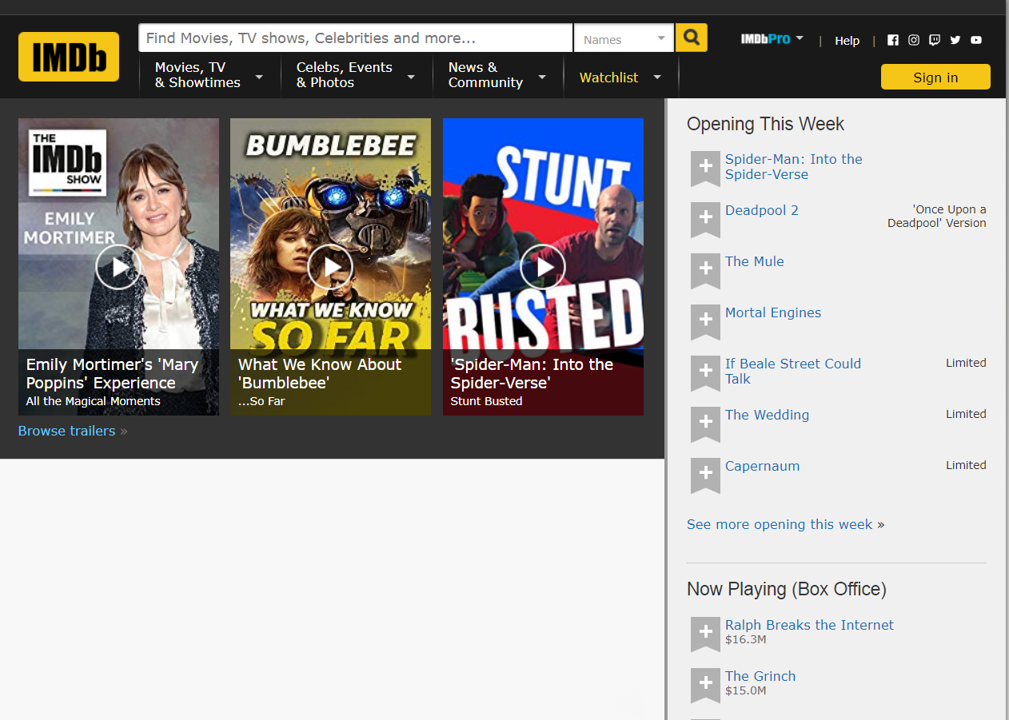

* Clicking on browse trailers redirects the user to a new page which displays the trailers (most popular, most recent, tv tonight) as follows:

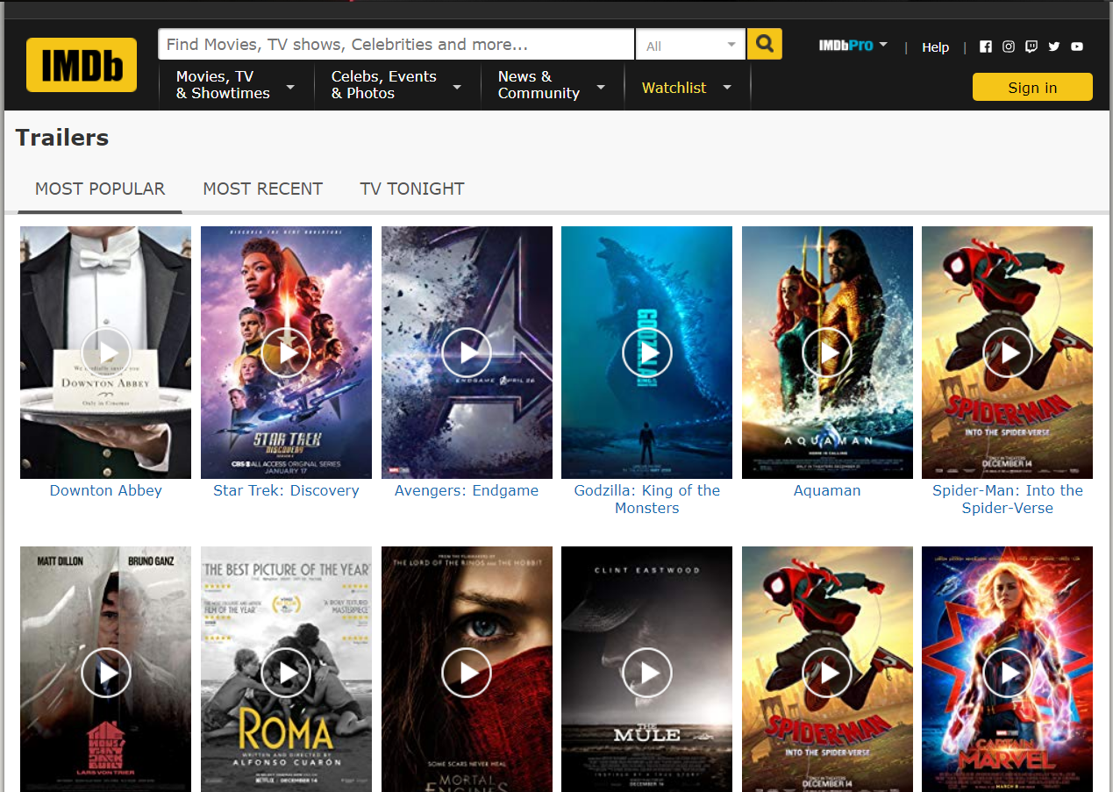

* Performing search by choosing name as “Fantastic Beasts: The Crimes of Grindelwald (2018)” and search field as “Title” redirects the user to the search results page:

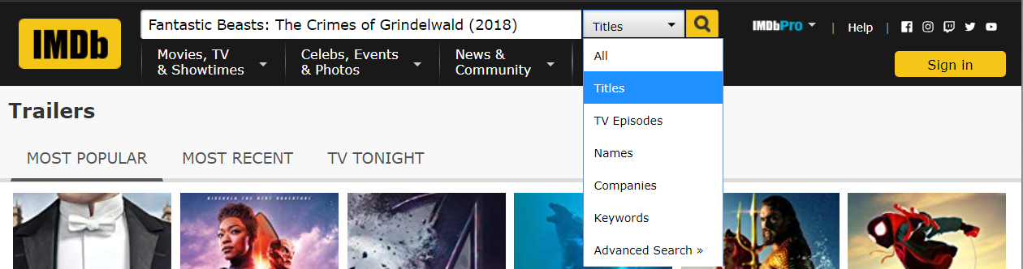

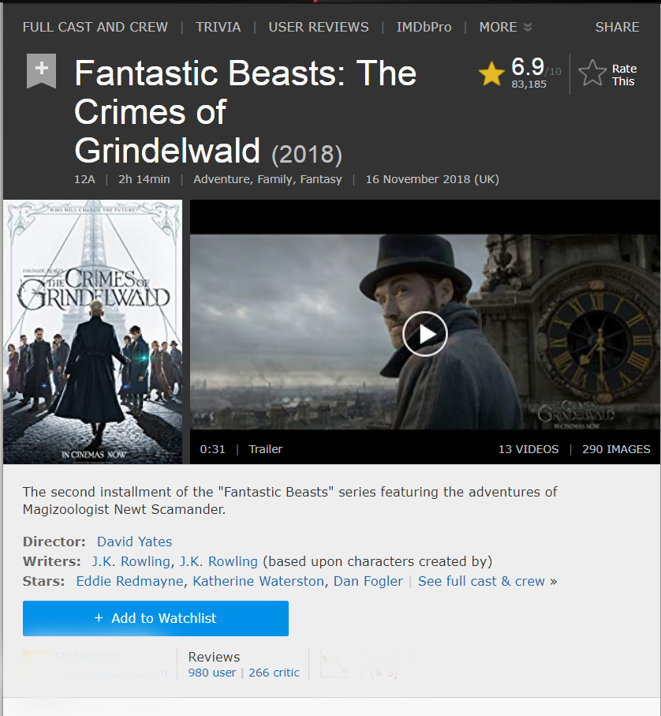

Your task is to work out the back-end architecture that supports these requests using the MVC pattern. The three requests are summarized as follows:

* <https://www.imdb.com/Home>/Index
* <https://www.imdb.com/Home/Trailers>
* <https://www.imdb.com/Home/SearchResult>

1. List the MVC based folder structure of your application and mention the file names. (5 marks)
2. Define the schema for the application (5 marks)
3. Write the code for the middleware that processes these requests and sends appropriate response (6+9+7 marks)

|  |  |
| --- | --- |
|  | **Section A** |

1. If the robots.txt file contains the following instructions for web crawlers, it means: (1 mark)

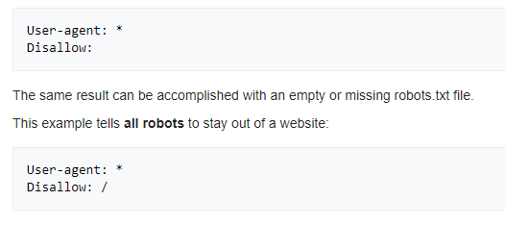

1. All robots can visit all files
2. All robots should stay out of the website
3. None of the above
4. Explain the execution and resulting output of the following script? (2 marks)

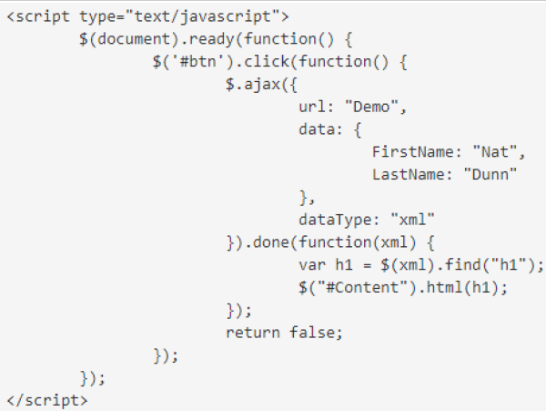

1. You need to add a custom Angular JS filter defined to format the “distance” to be displayed in kilometers. Given the Angular module getter syntax

angular .module('loc8rApp') .controller('locationListCtrl', locationListCtrl)

and given the following pug template snippet

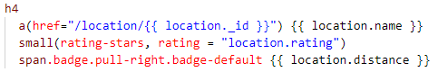

How will you chain the “formatDistance” filter to the Angular module getter syntax and how will you apply to filter to the pug template? (2 marks)

1. Once you make changes to your existing local Git repo, you need to push those changes online. What is the sequence of commands to achieve that? (2 marks)

1. Before the data from a form is stored it must be validated and sanitized. Validation checks that entered values are appropriate for each field (are in the right range, format, etc.) and that values have been supplied for all required fields. What does sanitization do? (1 mark)

|  |  |
| --- | --- |
|  | **Section B** |

1. In .net ____________________________ framework is used to implement service-oriented architecture.
2. Html Helpers can be of strongly typed as well as non-strongly typed?
3. True b) False
4. By Default, ASP.Net Session ID is stored in _________.
5. Application b) Session
6. Cookies d) View State
7. What is the last event of web page life cycle?
8. Page_Load b) Page_Complete
9. Page_Finish d) Page_Unload
10. What happens in the Init event of a page?
11. View State is loaded on the page.
12. Each child control of the page is initialized to its design time values.
13. HTML is rendered.
14. None of the above.
15. What are the advantages of using HTML helpers in MVC? (1)
16. How can we send multiple objects of different classes from controller to view? Explain using example (1)
17. How Ajax call works? (1)

**National University of Computer and Emerging Sciences, Lahore Campus**